Bending light

Light can bend when it enters or leaves a glass block.

a. Which glass block do you think bends the light the most?
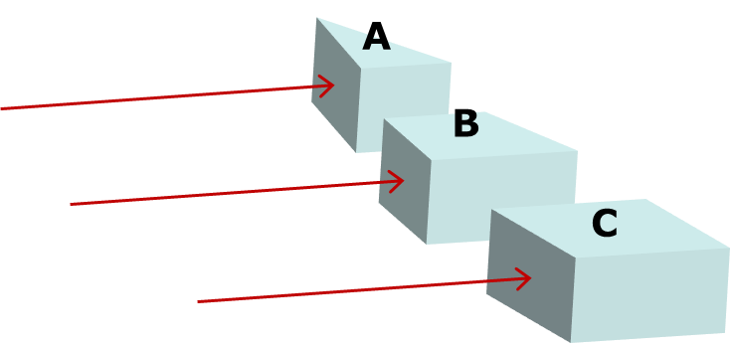

b. What is the best reason for your choice of glass block?
Put a tick (✓) in the box next to the best answer.
A | Light goes through the most glass
B | Light goes through the least glass
C | It is the most unusual shape
D | Light hits at the biggest angle
E | Light hits at the smallest angle

Physics > Big idea PSL: Sound, light and waves > Topic PSL3: Making images > Key concept PSL3.2: Refraction and lenses
Diagnostic question
Bending light

Overview
Learning focus: | All light from each point of an object that passes through a converging lens is bent (refracted) to a corresponding point in a sharp image.
Observable learning outcome: | Describe how the angle light passes across a boundary between two transparent media affects how much it is bent (refracted).
Question type: | Two-tier multiple choice
Key words: | Refract, refraction

What does the research say?
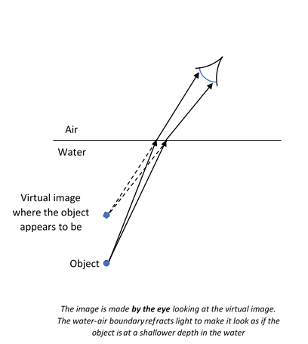
A common strategy for teaching students about refraction is to demonstrate examples of refraction phenomena and to explain the observations using ray diagrams that show how light is bent by glass blocks. In this approach students may use a ray box to explore how light travels through a parallel sided glass block to understand the nature of refraction. They change the angles of incidence to establish: a change of direction only occurs at an interface; light travelling perpendicular to the interface is not refracted; and light bends towards the ‘normal’ when entering more dense medium and vice versa (Tear, 2011).
Students often think of an image as a physical replication of an object which can travel, remain still or turn as a whole. They may ascribe active powers to mirrors, lenses or pinholes to manipulate images in order to explain how they appear in a particular way on a screen (Galili and Hazan, 2000). For example, Galili and Hazan (2000) found that over half of 14- to 15-year olds (n=64) thought that when a converging lens is removed, the inverted image it forms is replaced by an image the correct way up. These students are applying the misunderstanding that a lens actively flips an image that is already there.
Ways to use this question
Students should complete the questions individually. This could be a pencil and paper exercise, or you could use an electronic ‘voting system’ or mini white boards and the PowerPoint presentation. The follow on question will give you insights into how they are thinking and highlight specific misconceptions that some may hold.
If there is a range of answers, you may choose to respond through structured class discussion. Ask one student to explain why they gave the answer they did; ask another student to explain why they agree with them; ask another to explain why they disagree, and so on. This sort of discussion gives students the opportunity to explore their thinking and for you to really understand their learning needs.

Differentiation
You may choose to read the questions to the class, so that everyone can focus on the science. In some situations it may be more appropriate for a teaching assistant to read for one or two students.
Expected answers
a. A – the triangular prism.
b. D – Light hits at the biggest angle.
How to respond - what next?
Glass block C suggests that students have the misunderstanding that an image or light ray is affected continuously through the block. This is confirmed with answer A to part b.
The choice of block A or B suggests students understand that the bending of light is caused by a block’s lack of symmetry that can affect the light in one direction. This is confirmed by answers C or D to part b. Answer C indicates students who recognise asymmetry predicts a change of direction, but who have not understood the reason for the change.
Answers B and E are included in part b to avoid leading students’ thinking.
If students have the misunderstanding about why block A bends light the most, it can help to lead a structured class discussion about what asymmetries there are that could cause a change in one particular direction. This can be followed up using the following BEST ‘response activity’ to confirm the correct science explanation by tracing rays of light through a glass block:
- Response activity: Refraction
Acknowledgments
Developed by Peter Fairhurst (UYSEG).
Images: Peter Fairhurst (UYSEG).
References
Galili, I. and Hazan, A. (2000). Learners' knowledge in optics: interpretation, structure and analysis. International Journal of Science Education, 22(1), 57-88.
Tear, C. (2011). Sound, light and waves. In Sang, D. (ed.) Teaching secondary physics. London: Hodder Education.

